**PHYSICAL CHEMISTRY ASSIGNMENT**

THE PRINCIPLE INSTRUMENTATION AND APPLICATION OF POLAROGRAPHY

Submitted By: A.KUPPUCHAMY (19CHP032)

**Theory and Applications of Polarography**

Voltammetry comprises a group of electro analytical methods in which information about the analyte is derived from the measurement of current as a function of applied potential obtained under conditions that encourage polarization of the indicator or working electrode. Generally, the working electrodes in Voltammetry are characterized by their small surface area that enhances polarization. Such electrodes are generally referred to as micro electrodes.

Polarography is that branch of Voltammetry in which changes in current, resulting from the electrolysis of the solution under study are 27 general principles of polarography investigated using a renewable mercury droplet as the indicator electrode (cathode). The anode of the electrolytic cell called the reference electrode consists of either a mercury pool at the bottom of the cell or a calomel electrode.

**Theory of operation**

Polarography is a voltammetric measurement whose response is determined by only diffusion mass transport. The simple principle of polarography is the study of solutions or of electrode processes by means of [electrolysis](https://en.wikipedia.org/wiki/Electrolysis) with two [electrodes](https://en.wikipedia.org/wiki/Electrodes), one polarizable and one unpolarizable, the former formed by mercury regularly dropping from a [capillary tube](https://en.wikipedia.org/wiki/Capillary_tube). Polarography is a specific type of measurement that falls into the general category of linear-sweep voltammetry where the electrode potential is altered in a linear fashion from the initial potential to the final potential. As a linear sweep method controlled by convection/diffusion mass transport, the current vs. potential response of a polarographic experiment has the typical [sigmoidal shape](https://en.wikipedia.org/wiki/Sigmoid_function). What makes polarography different from other linear sweep voltammetry measurements is that polarography makes use of the [dropping mercury electrode](https://en.wikipedia.org/wiki/Dropping_mercury_electrode) (DME) or the static mercury drop electrode.

A plot of the current vs. potential in a polarography experiment shows the current oscillations corresponding to the drops of Hg falling from the capillary. If one connected the maximum current of each drop, a sigmoidal shape would result. The limiting current (the plateau on the sigmoid), called the diffusion current because diffusion is the principal contribution to the flux of electroactive material at this point of the Hg drop life.

A schematic diagram of a simple polarographic set up is shown in below figure.

Where,

DME : Dropping Mercury Electrode;

T.S : Test solution;

J : Agar bridge;

SCE : Saturated Calomel Half-cell;

P : Potentiometer or Polarography;

B : Battery;

G : Galvanometer;

h : Height of Mercury Column.

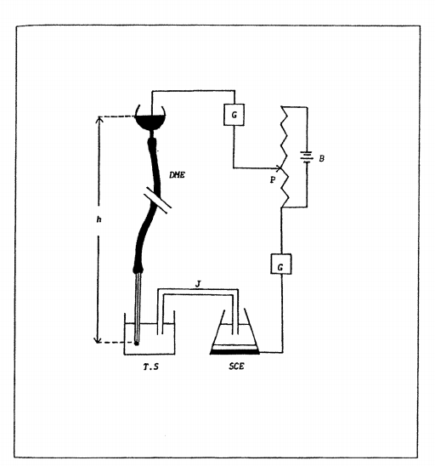

Fig. 2: Schematic diagram of essentials for polarographic analysis.

**Polarographic Currents**

The total current that flow in, consists of the following components:

* Residual Current
* Migration Current
* Diffusion Current

**Residual Current**

The current that flows in the absence of the depolarizer (i.e. due to the supporting electrolyte) is called residual current. This has to be taken into consideration while interpreting the polarograms.

**Migration Current**

It is the current due to migration of ions caused by the electrostatic field between the two polarographic electrodes. The contribution of this component is minimized under experimental conditions by taking large concentrations of the supporting electrolyte. Under these conditions, only ions of the supporting electrolyte migrate in electrostatic field. The ions of the depolarizer do not take part in migration. They reach the surface of the electrode by the process of diffusion.

**Diffusion Current**

Diffusion current is due to electroactive substances. When the potential of the d.m.e is in the plateau region the electroactive ions or molecules are reduced or oxidized as soon as they reach the electrode surface. As a result they are consumed and their concentration in a thin layer of solution in contact with the electrode becomes zero.

**Applications of Poiarography**

Polarographic analyses can be used directly for the determination of any substance solid, liquid, or gaseous, organic or inorganic, ionic or molecular that can be reduced or oxidized at dropping mercury electrode. One of the most important advantages of poiarography is the determination of two or more substances by obtaining a single current-potential curve. Another important technique is the Amperometric titration which involves polarographic measurements. In addition to analytical uses, poiarography is one of the most fruitful techniques of research in physical, inorganic and organic chemistry. This technique is spreading more widely in subsidiary fields like biochemistry, pharmaceutical chemistry, environmental chemistry and others. It is being 49 general principles of polarography used to study diverse topics as hydrolysis, solubility, complex formation, and adsorption, the stoichiometry and kinetics of chemical reactions, the mechanisms of electrode reaction and of chemical reactions accompanying them, standard and formal potentials, molecular dimensions, the effects of structure on reactivity and many others of interest and importance.

**Limitations**

There are limitations in particular for the classical polarography experiment for quantitative analytical measurements. Because the current is continuously measured during the growth of the Hg drop, there is a substantial contribution from capacitive current. As the Hg flows from the capillary end, there is initially a large increase in the surface area. As a consequence, the initial current is dominated by capacitive effects as charging of the rapidly increasing interface occurs. Toward the end of the drop life, there is little change in the surface area which diminishes the contribution of capacitance changes to the total current. At the same time, any redox process which occurs will result in faradaic current that decays approximately as the square root of time (due to the increasing dimensions of the Nernst diffusion layer). The exponential decay of the capacitive current is much more rapid than the decay of the faradaic current; hence, the faradaic current is proportionally larger at the end of the drop life. Unfortunately, this process is complicated by the continuously changing potential that is applied to the [working electrode](https://en.wikipedia.org/wiki/Working_electrode) (the Hg drop) throughout the experiment. Because the potential is changing during the drop lifetime (assuming typical experimental parameters of a 2 mV/s scan rate and a 4 s drop time, the potential can change by 8 mV from the beginning to the end of the drop), the charging of the interface (capacitive current) has a continuous contribution to the total current, even at the end of the drop when the surface area is not rapidly changing. As such, the typical signal to noise of a polarographic experiment allows detection limits of only approximately 10−5 or 10−6 M.

Improvements

Dramatically better discrimination against the capacitive current can be obtained using the tast and pulse polarographic techniques. These have been developed with introduction of analog and digital electronic potentiostats. A first major improvement is obtained, if the current is only measured at the end of each drop lifetime (tast polarography. An even greater enhancement has been the introduction of differential pulse polarography. Here, the current is measured before the beginning and before the end of short potential pulses. The latter are superimposed to the linear potential-time-function of the voltammetric scan. Typical amplitudes of these pulses range between 10 and 50 mV, whereas pulse duration is 20 to 50 ms. The difference between both current values is that taken as the analytical signal. This technique results in a 100 to 1000-fold improvement of the detection limit, because the capacitive component is effectively suppressed.